Midterm Report

In order to complete this project, we knew that we needed to use HTML, CSS, and JavaScript to create a functioning website. Our first step was studying these languages via YouTube videos and Google. We also utilized W3Schools.com to assist with webpage design using CSS and HTML. At this stage in the project, we are focusing on the front-end. Our project so far consists of a sign up page, sign in page, and home page. The sign up page allows a new user to create an account with their Bowie State email and a password. We are currently storing the information using local storage, however we plan to build a back-end that will allow for cross-platform storage.

The sign up page requires the user to confirm their password by entering it twice. We have added password security functionalities to ensure that the two passwords match. We have also added a feature to detect the security strength of a password. This strength is gauged by the use of uppercase characters, lowercase characters, special characters, and numbers. If a user only uses upper and lowercase characters, then it will notify them that their password is weak. If they use three out of four factors, the password is medium strength and if they use all four characters, the password is strong. The sign up and sign in pages also verify the user email. If an invalid email is entered, the user will be notified. Additionally, the user must use a Bowie State email, otherwise they will be notified that the email must be from BSU.

When a user first reaches the website, they will use the sign in page. If the user has not yet created an account, there is a link to go directly to the sign up page. Once they enter their information, the site will go to the homepage with their username in the top right corner of the screen. As mentioned earlier, once a user creates their account, we are able to store that users email in local storage then they are able to use it in the sign in page. If the user enters an incorrect password during sign in, they will receive an alert stating the password was incorrect.

Our homepage displays the users bank balance, allows them to make deposits, make withdrawals, and sign out of their account. If the user decides to sign out, they will be logged out and redirected to the sign in page. The homepage data is also stored using local storage. For example, if a user deposits or withdrawals money from their account, the new balance will be updated and saved to that account. If the user logs out and logs back in, the balance will show the updated amount.

We have used CSS to enhance the look and design of our pages. The sign in and sign up pages display a picture of the Mathematics and Science building from the Bowie State campus. We added shading and background colors to headers and links to provide better visibility and readability to the user. We also added the hover effect to the links so when the user hovers over each link, it changes color and adds a background for readability. Next steps include adding more style and functionality to our homepage. Right now, it’s just a simple yellow and white background with the BSU logo in the top left corner.

We have learned basic HTML, CSS, and JavaScript coding to create a basic front-end page for the user to login. Our plan moving forward is to continue building and editing our homepage. Once we have built up the homepage, we will begin working on a back-end to store and retrieve our data for cross-platform storage. As mentioned earlier, we are currently using local storage but, in the future, we could use CSV files or MySQL to hold user account information. The CSV knowledge we learned from the in-class lab will help us set up that database. The Git and GitHub YouTube videos we watched during week 3 will also help us collaborate as a team and share our work. We have set up a GitHub repository for our project where we are able to share versions of the code. This repository can be found using the following URL: <https://github.com/ruffin479/bankProject.git>.

**\*See next pages for screenshots of results\***

**Login Page:**

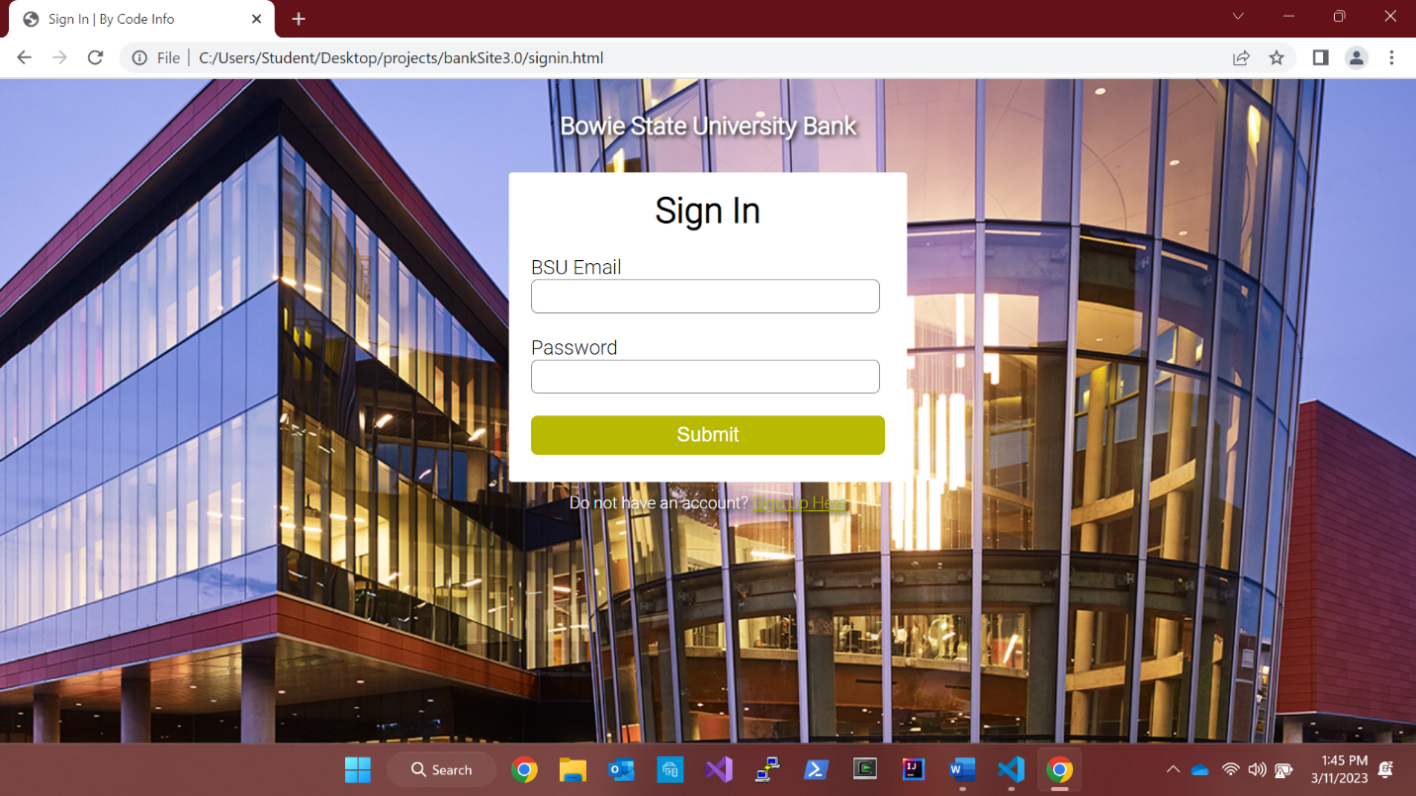

**Login Page Incorrect Password:** 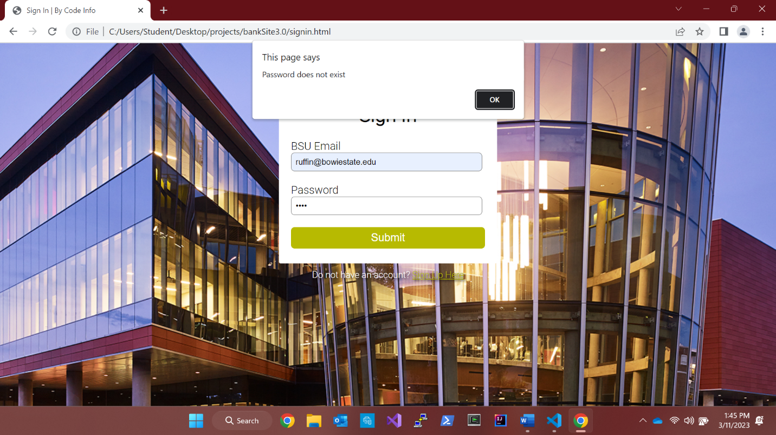

**Login Page Incorrect Email:** 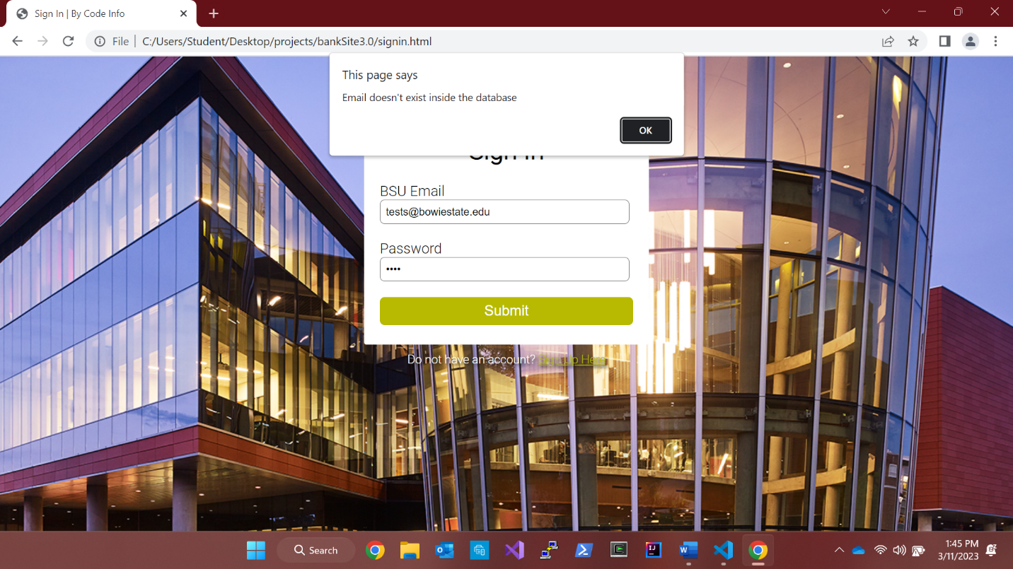

**Sign Up Page Password Strength:**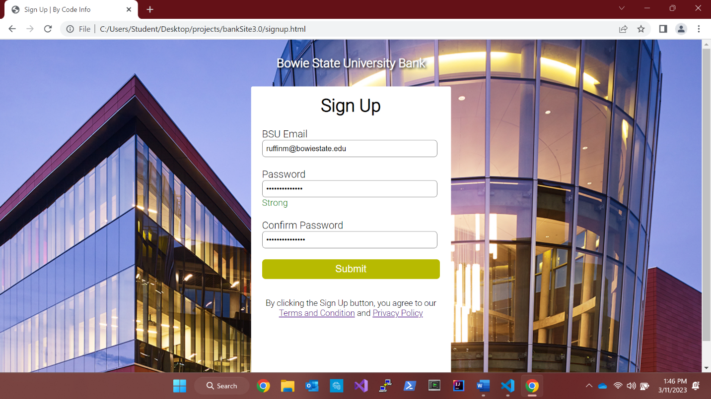

**Sign Up Page Unmatched Passwords**: